CLOUD COMPUTING PLATFORM –
JAVA GUI PROJECT

A Role-Based Cloud Resource
Deployment & Monitoring System
CSE(DS) Sem-3rd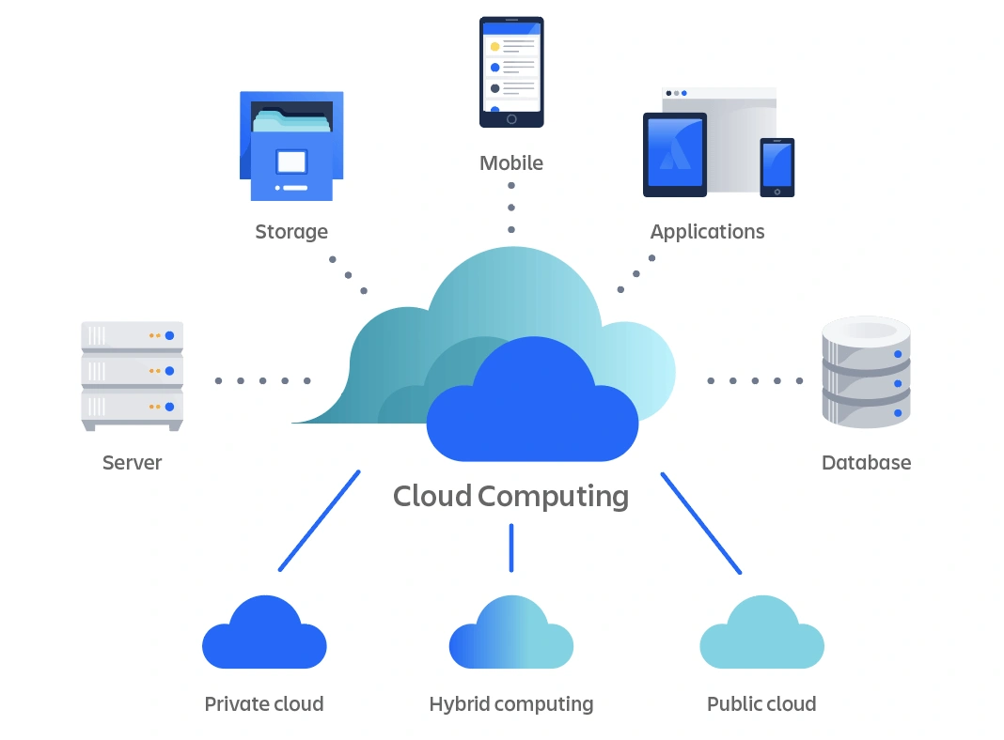
Section-33 Java programming :- R1UC304C

PROBLEM STATEMENT & PROJECT OBJECTIVES
# Problem Statement :-
# Cloud systems lack central resource control.
# Manual monitoring & billing are inefficient.
# Role-based secure access is missing.
# Real-time performance visibility is required.

# Project Objectives :-
# To build a role-based cloud management platform.
# To provide real-time monitoring (multithreading)
# To enable cloud deployment with database storage
# To use Java Swing + JDBC + OOP for simulation.

Architecture & File Structure
#The project follows a modular architecture:-
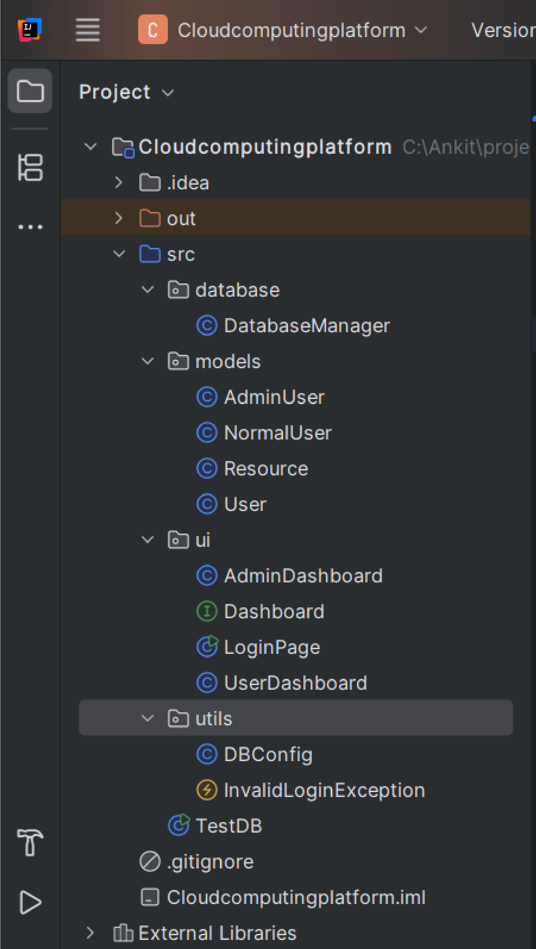
# Models→ Contains core OOP classes (User, AdminUser, NormalUser, Resource)
# U→ Contains GUI screens and dashboards for Admin & Users
# Database → Handles JDBC connectivity and all CRUD operations
# Utils → Configuration and custom exception handling # # #TestDB.java → Independent connection testing class
OOP Implementation
User (Base Class)
↑
┌───────────┴───────────┐
AdminUser (Child) NormalUser (Child)
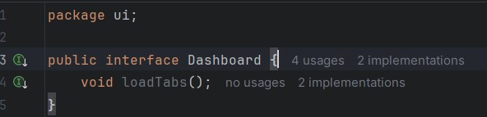
authenticateUser() returns AdminUser / NormalUser → Polymorphism
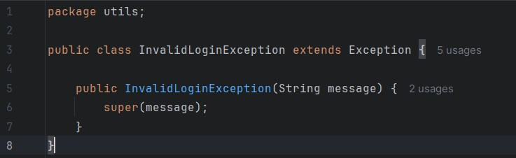
# Inheritance → AdminUser & NormalUser extend User
# Polymorphism → authenticateUser() returns dynamic object
# Abstraction → Dashboard interface implemented by both dashboards
# Encapsulation → Private fields with getters & setters (in models)
# Exception Handling → Custom InvalidLoginException for failed login

Collections & Generics
List<User> → Generics + Collection
List<Resource> → Generics + Collection
new ArrayList<>() → Concrete implementation of List
#Used List<User> and List<Resource> to store database records in memory.
# Used ArrayList as the concrete implementation of Java Collections.
# Generics ensure type safety while handling User and Resource objects.
# Enhanced for-each loop simplifies iteration over records for UI and debugging.
Multithreading &
Synchronization
SC - : Live CPU & RAM monitoring — dynamic values updated using background thread.
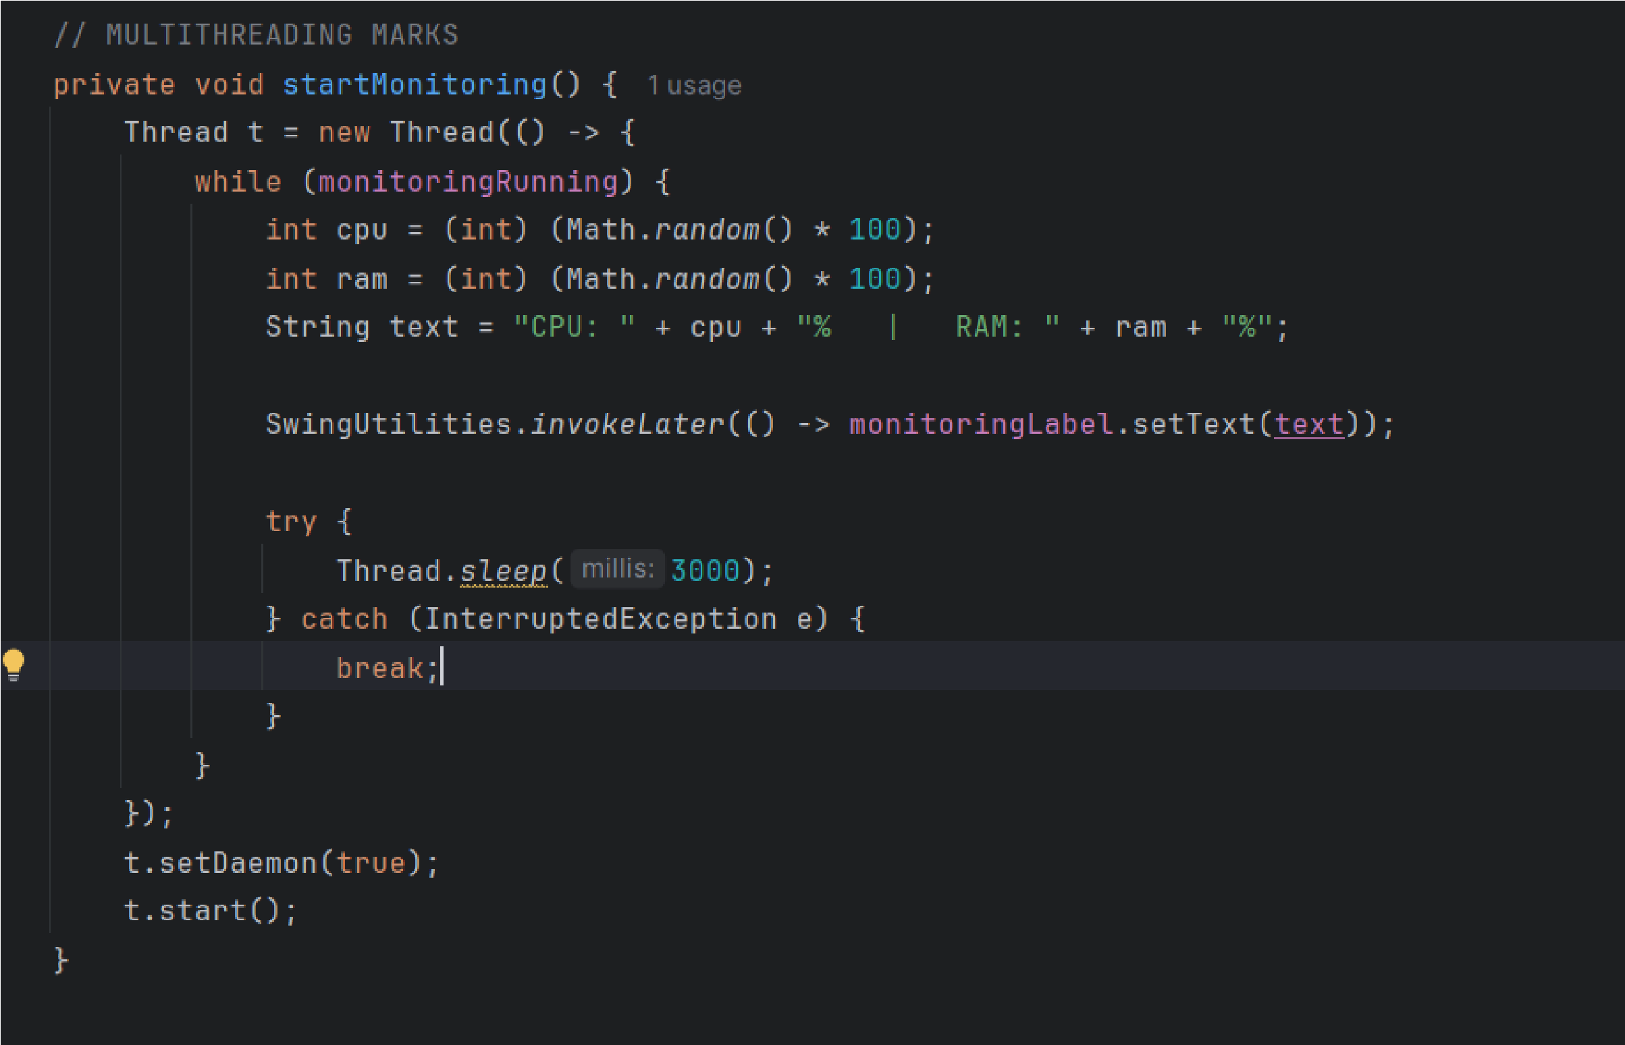
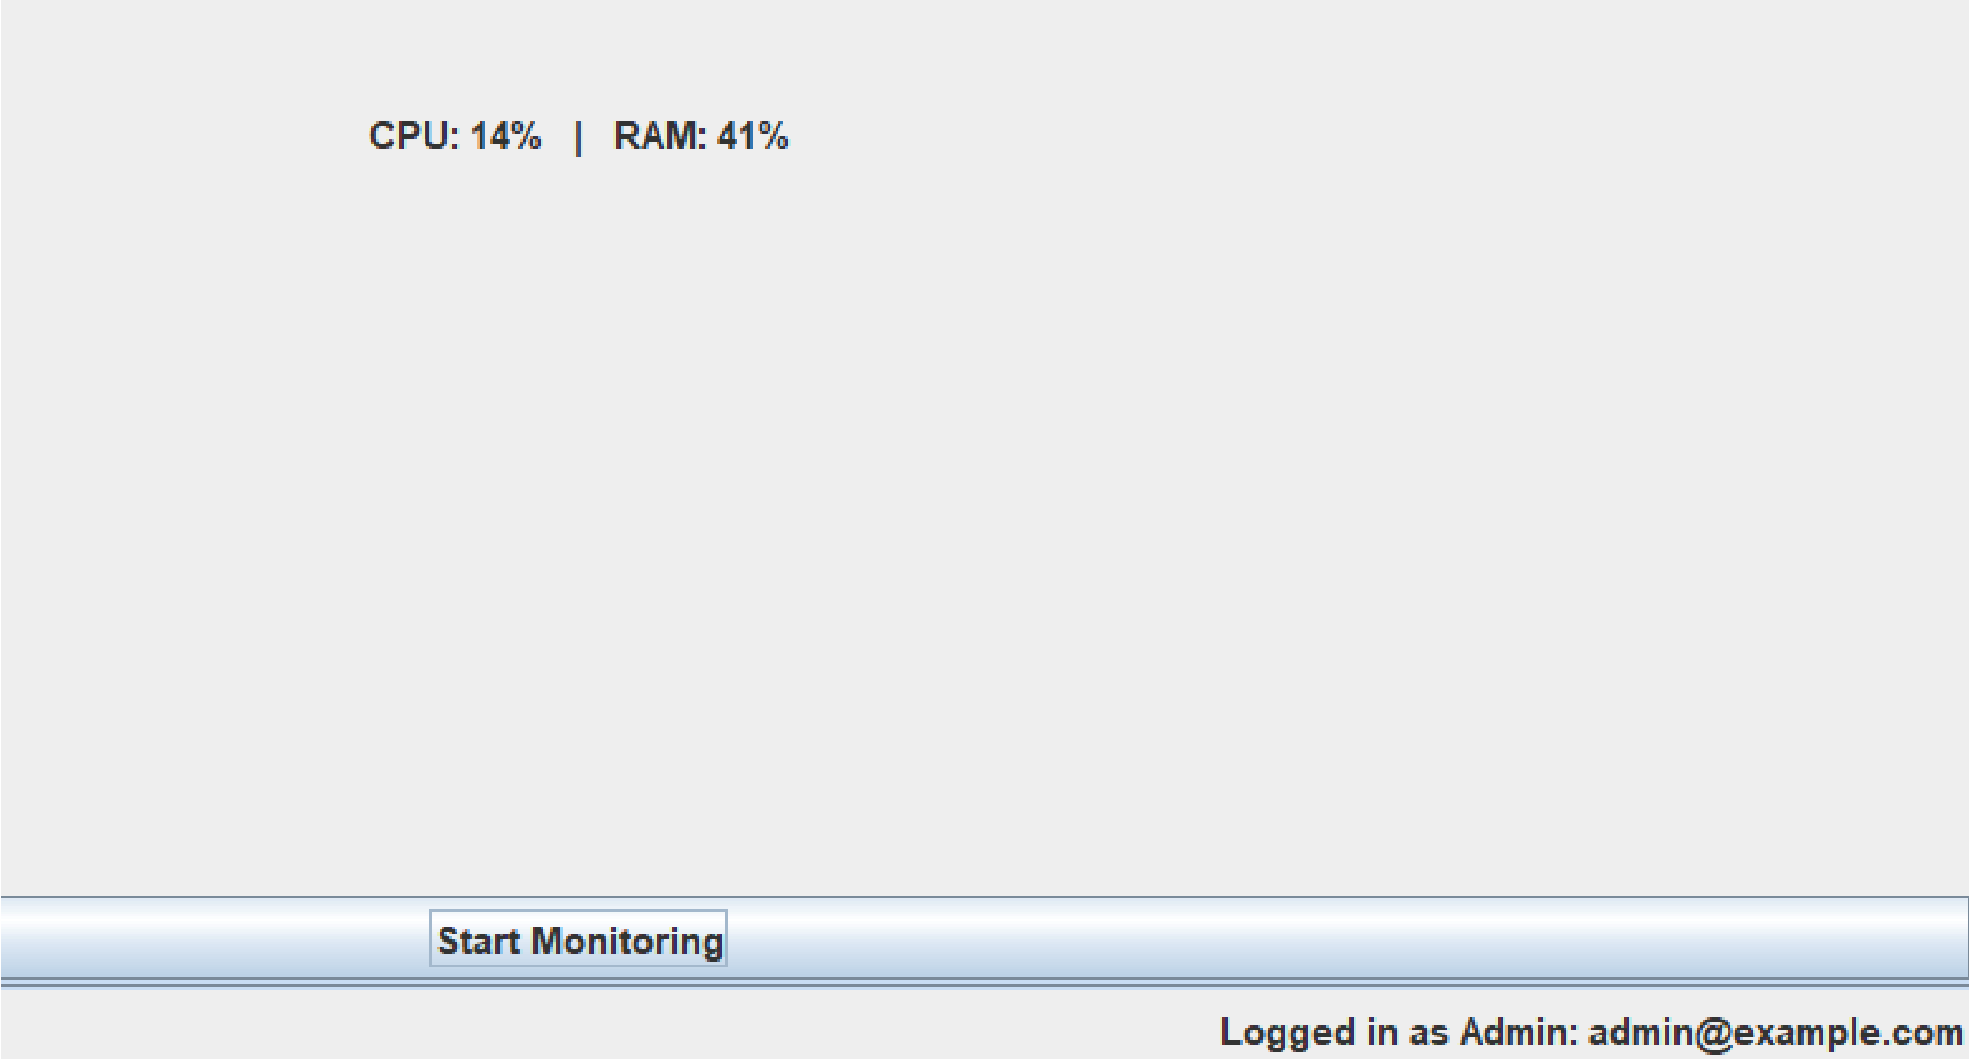
# A dedicated background thread performs real-time resourcemonitoring.
# The thread runs inside a loop and refreshes CPU & RAM usageevery 3 seconds.
# SwingUtilities.invokeLater() prevents UI freezing by safelyupdating Swing components from worker thread.
# A control flag (monitoringRunning) ensures safe start/stop ofthe monitoring thread — basic synchronization.

Database Schema & Database Operations
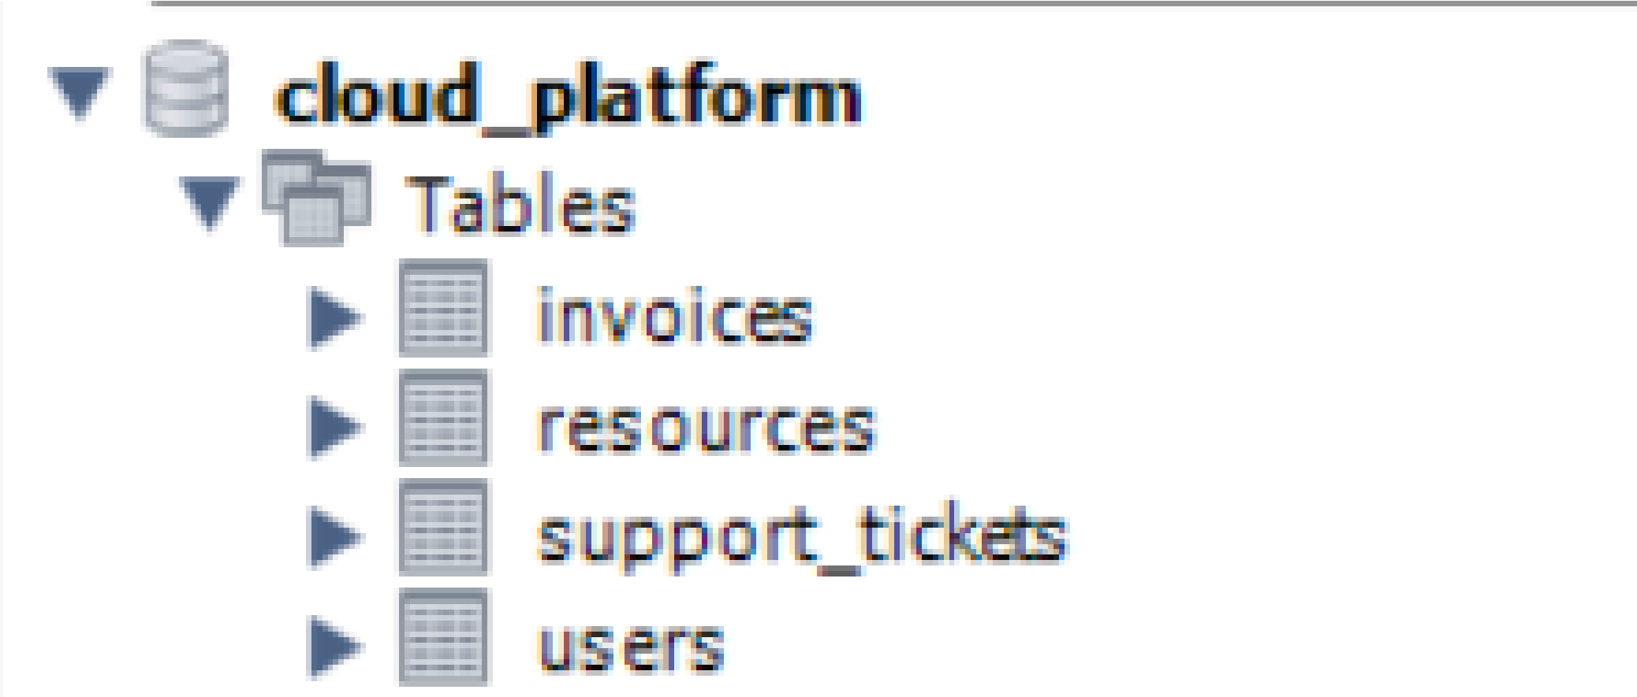
# A relational database schema is designed to store users and cloud resources with referential integrity.
# All database operations are centralized in DatabaseManager to maintain clean architecture.
# CRUD operations for Users and Resources are implemented using PreparedStatement to prevent SQL injection.

# Query results are mapped to model objects (User, Resource) instead of raw ResultSet for type safety and easier UIintegration.

JDBC Connectivity
# JDBC driver is loaded using Class.forName to enable MySQL connectivity.
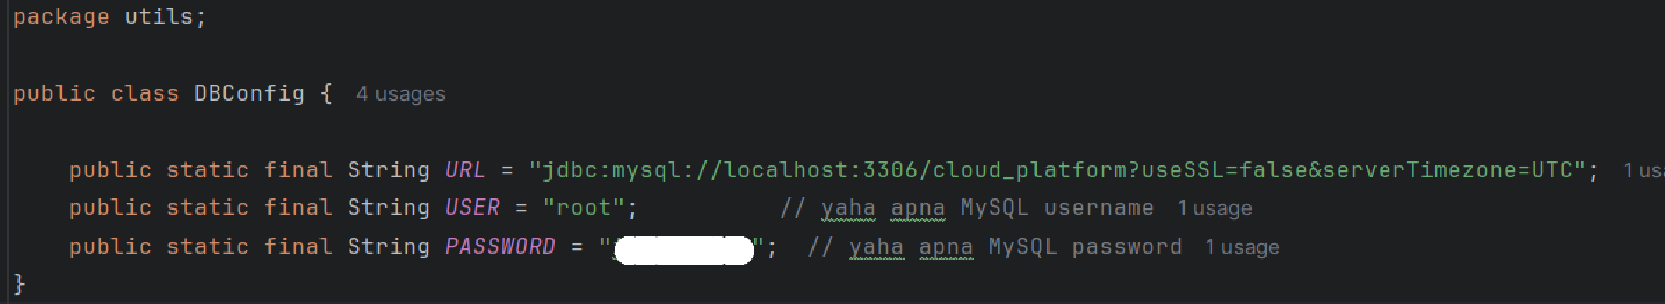
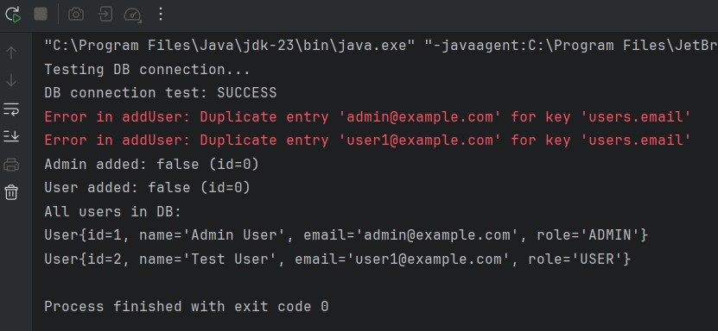
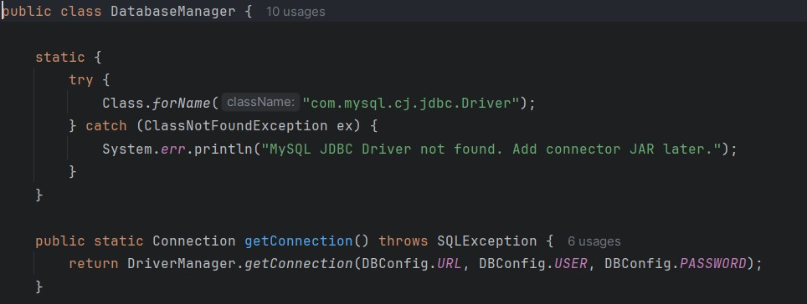
# A centralized DBConfig class stores URL, username and password independently ofapplication logic.
# The getConnection() method in DatabaseManager uses DriverManager to providereusable DB connections.
# TestDB validates connectivity and insertion queries before launching theapplication.

GUI Screens & Application Flow
- The application uses Java Swing to provide a clean and responsive GUI.
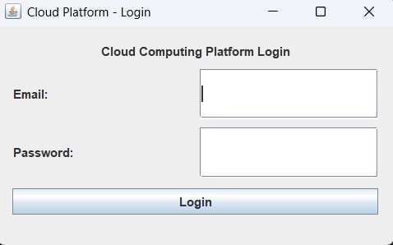
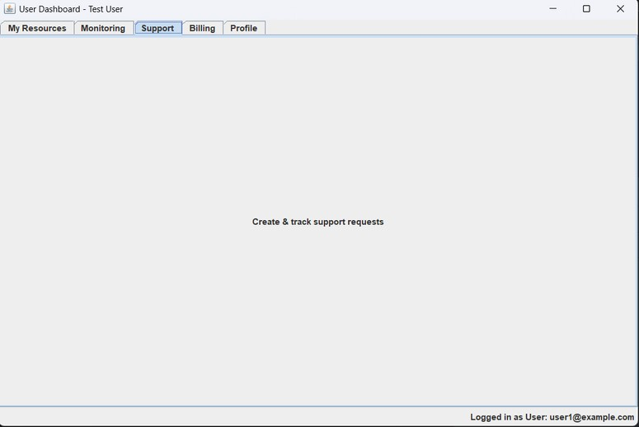
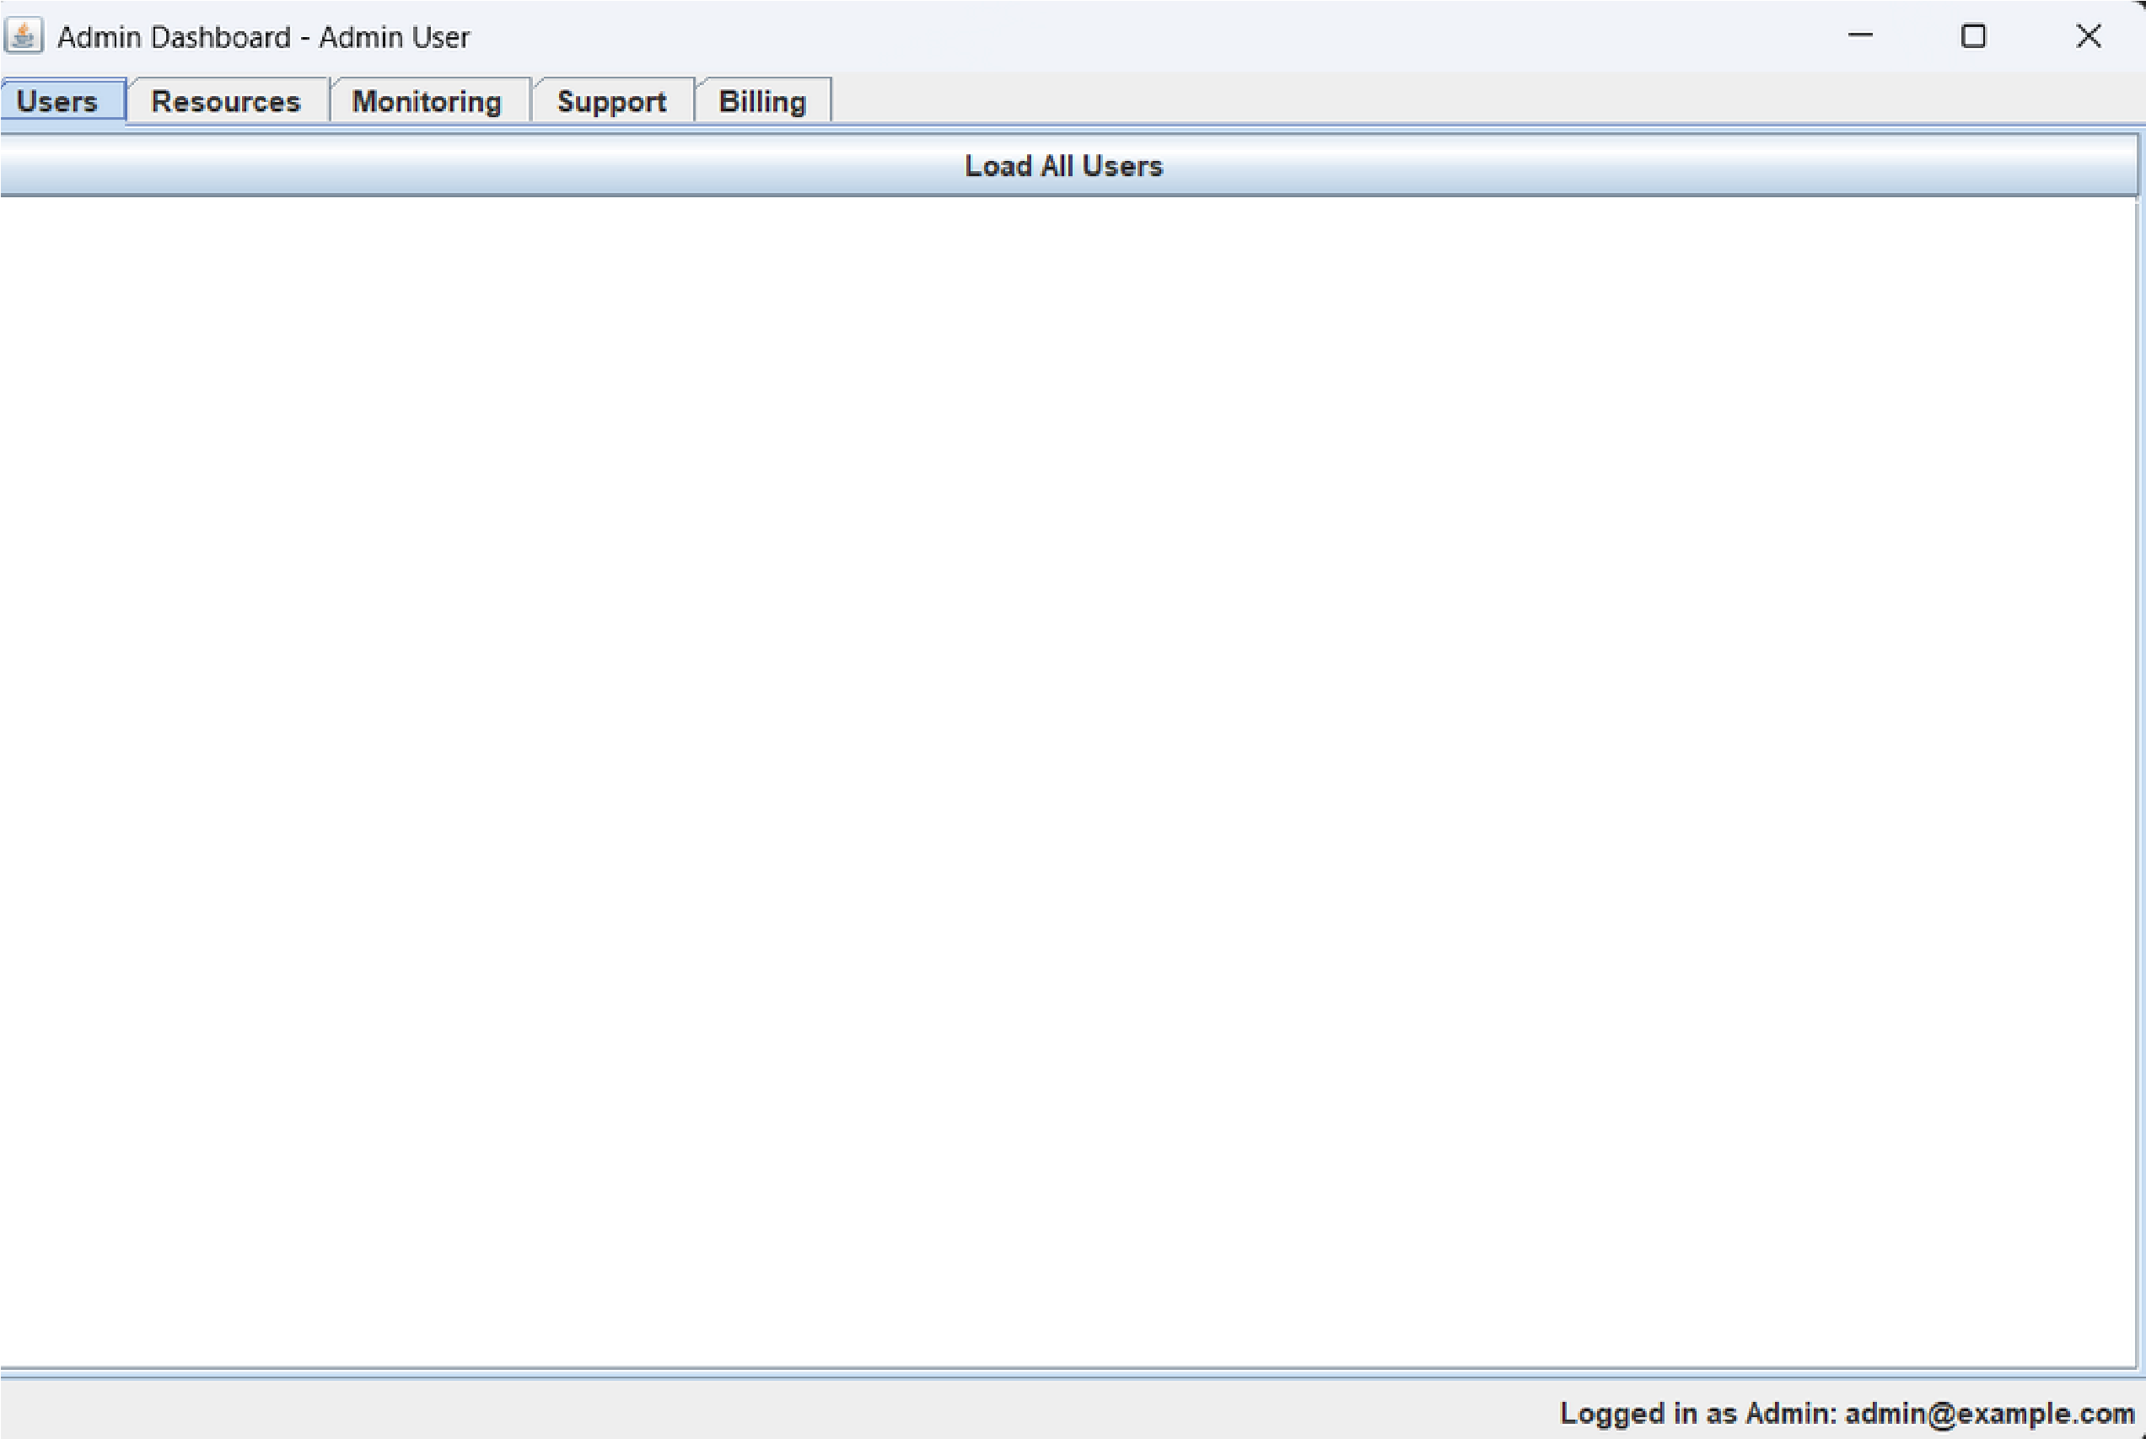

- LoginPage validates user credentials and redirects to role-specific dashboards.
- AdminDashboard provides multiple tabs for managing users, resources, monitoring, support and billing.
- UserDashboard allows normal users to view and manage their own resources and account-related information.
- # The tab-based layout makes the cloud platform easy to navigate and extend in future reviews.
Core Java & OOP concepts fully implemented:
  - Inheritance, Polymorphism, Abstraction, Encapsulation, Exception Handling
# Database layer completed
  - CRUD operations for Users & Resources using JDBC PreparedStatement
  - DB connection tested successfully via TestDB .

Review – 1 Summary & Deliverables

# Collections & Generics implemented:

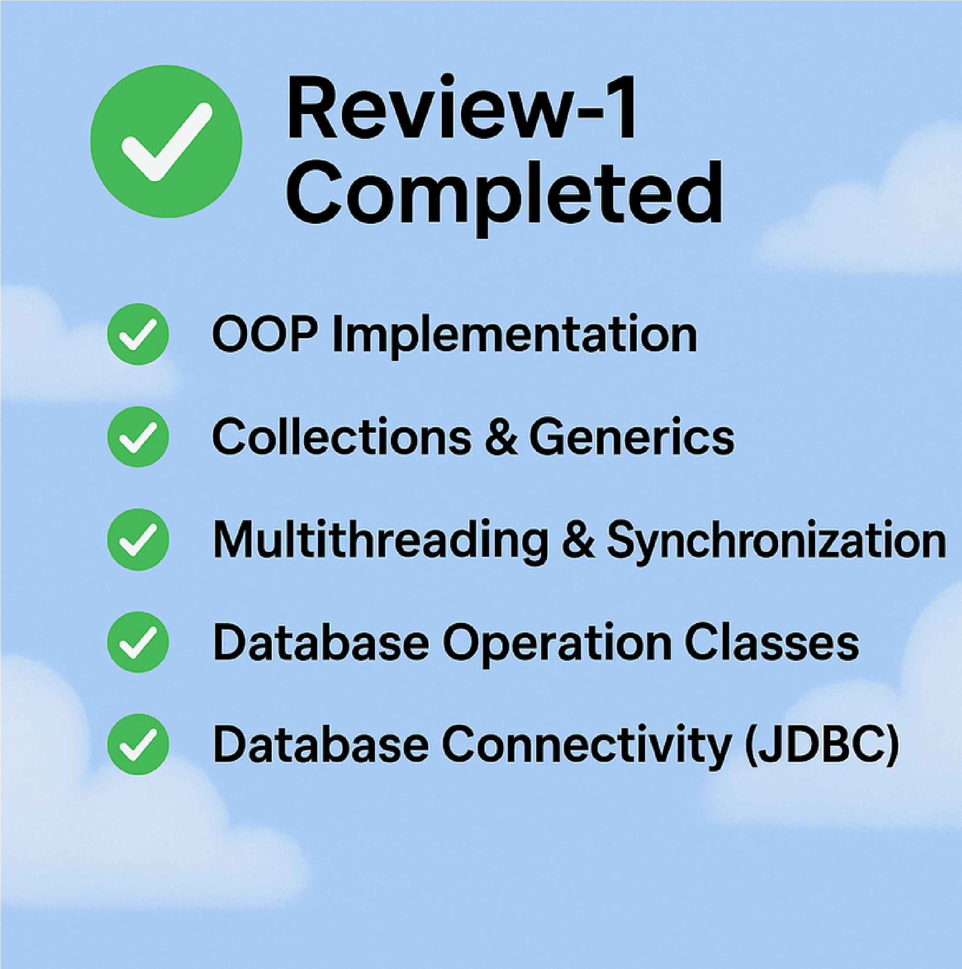
  - List<User> & List<Resource> for in-memory caching
  - Enhanced for-each loop for iteration
# Multithreading & Synchronization:
  - Background thread for live CPU & RAM monitoring .
• SwingUtilities.invokeLater for thread-safe GUI updates .
# Fully functional GUI:
  - Login page with validation .

Thank you
Submitted by :-
Prashant kumar (24scse1420132)
Piyush raj (24scse1420122)
Arth Pratap singh (14scse1420143)

